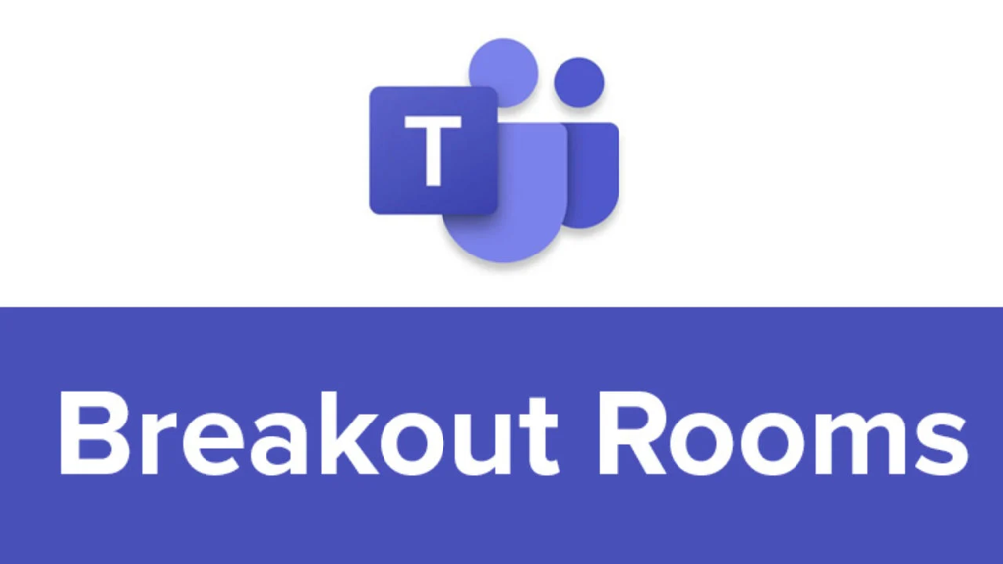

Breakout Rooms are finally here! Teachers from around the country have been asking for this feature for months!

Now, the teacher has the ability to put students into virtual breakout rooms within a team meeting. The teacher can assign students to specific rooms and start, stop, and join the meetings whenever he or she wants! When the teacher starts the breakout meetings, students are automatically launched into that small group meeting. When the teacher closes the room, the students automatically rejoin the whole class meeting. This could be a game changer for remote learners. No longer are they stuck observing the whole class. They can meet with each other to discuss and collaborate without interrupting the whole class meeting!

Creating and using Breakout Rooms is simple, so let’s get started!

To use the new breakout rooms, you need to enable the new team meeting experience. To do this, find your initials in the circle in the upper right-hand corner of the Teams app on the Mac or PC. Click on it. Click on Settings. Click on “Turn on new meeting experience.”

Now, along with some other great features in the new experience, you can create those Breakout Rooms!

When you first get into Teams after enabling the new experience, you will notice it looks a little different.

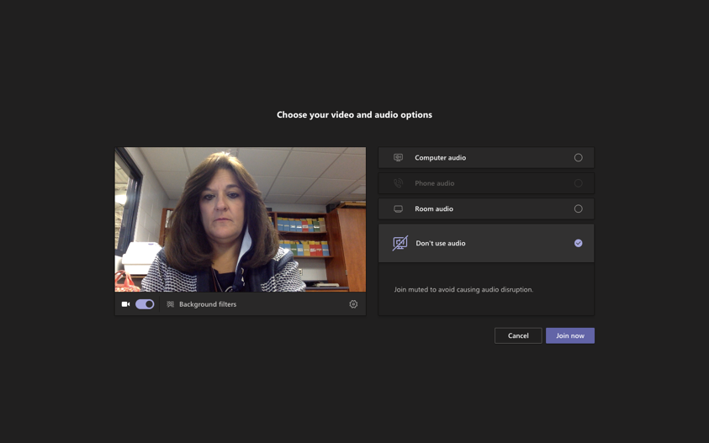

Instead of all of your “join” options being at the bottom of your screen, they are in the middle. Under your image, you will see your option to turn on/off your video and to blur your background. To the right, you will see your audio options. We will use computer audio to join. When you have selected the options you want, click Join Now.

Once in the meeting, the main thing you will notice is that the toolbar is now stationary at the top of the screen. The Breakout Room option is next to the three dots. Click on it to begin.

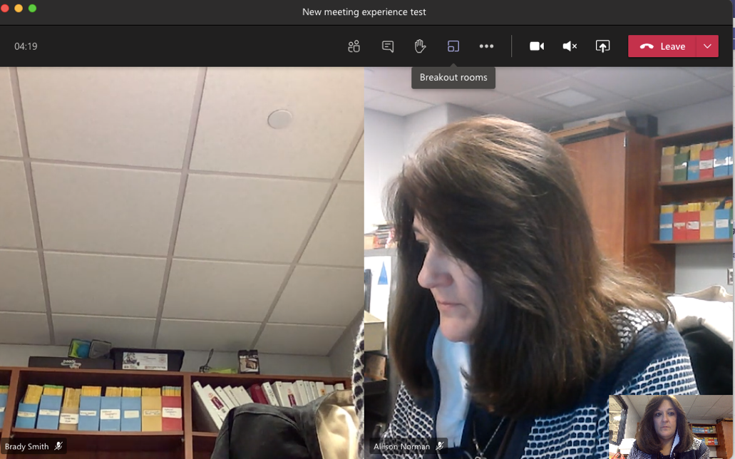

Once you click on Breakout Rooms, a new screen will appear in which you can create rooms.

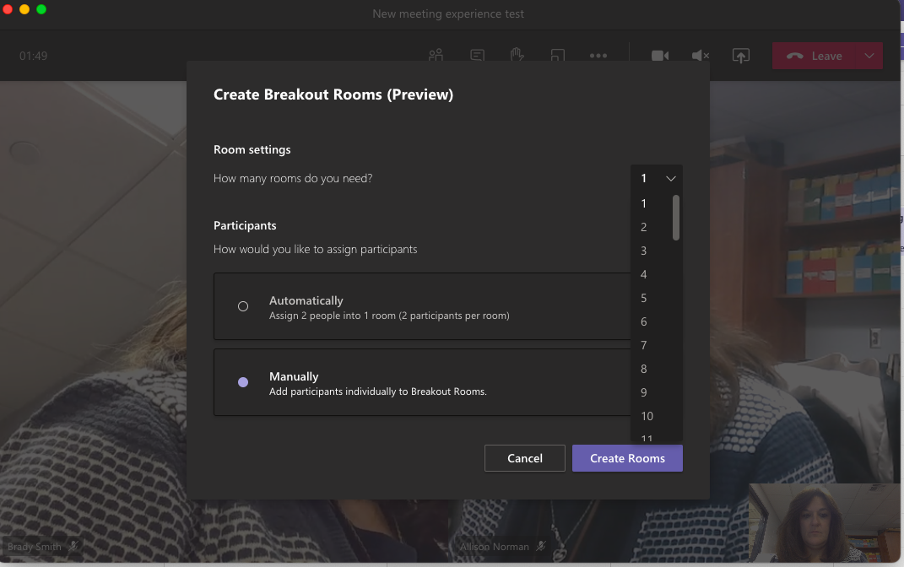

Tell Teams how many rooms you want, and how you want to assign participants to the rooms. You can let Teams randomly assign students by clicking Automatically. If you want to put students in rooms yourself, click Manually. Then, click Create Rooms.

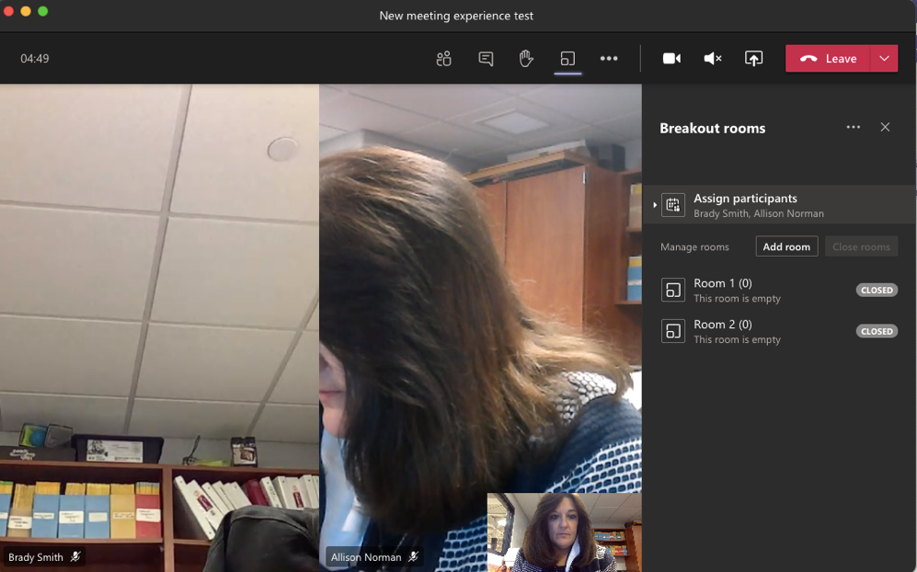

Now it is time to assign participants. Click on Assign Participants.

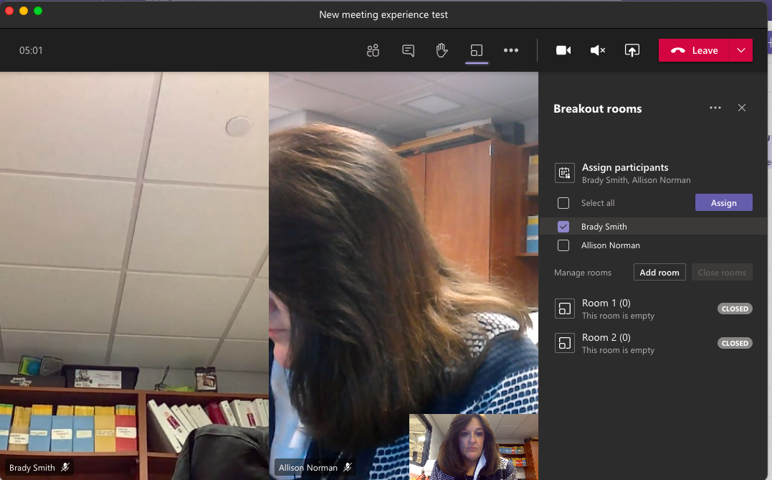

When the new box appears, click to select the students you want in a room together.

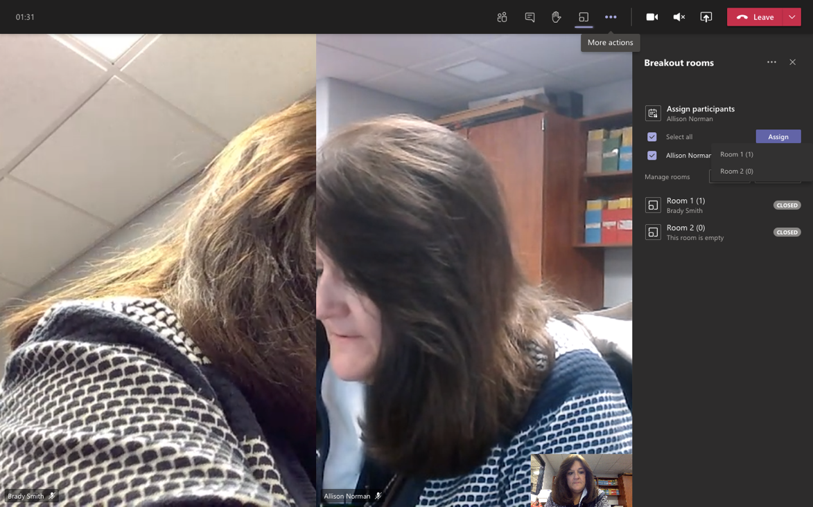

When you are done selecting students for the first room, click Assign. You will then be able to choose which room in which to put the students. If a student joins a meeting AFTER you have already assigned rooms, simply click on Assign participants again and put them into a room. If several students join late, you might want to just recreate the rooms from scratch. Go to the three dots next to the words Breakout Rooms in the upper right-hand corner. Click on recreate rooms.

If you find you are in need of another room or two, simply click on Add Room.

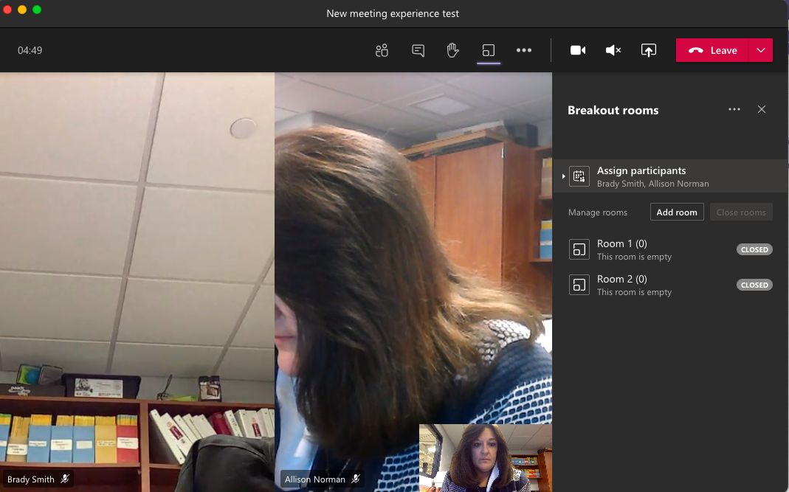

Once you have created the rooms and assigned the students to them, now you can choose to open the rooms (start the breakout meeting) whenever you want.

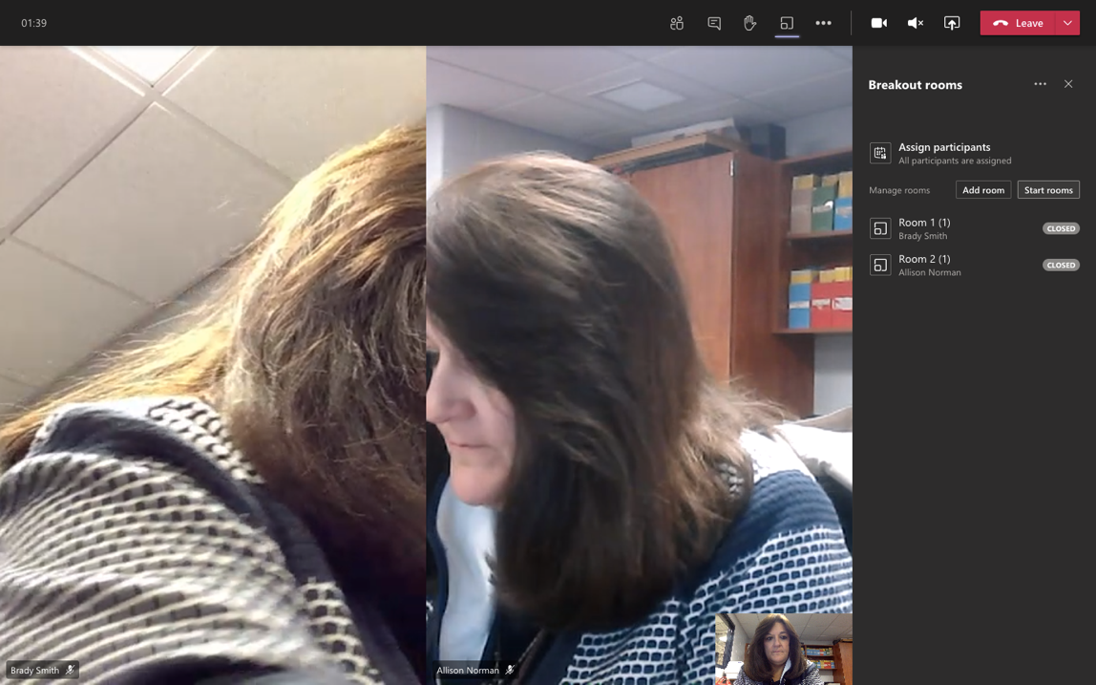

To start the breakout meetings, simply click Start Rooms.

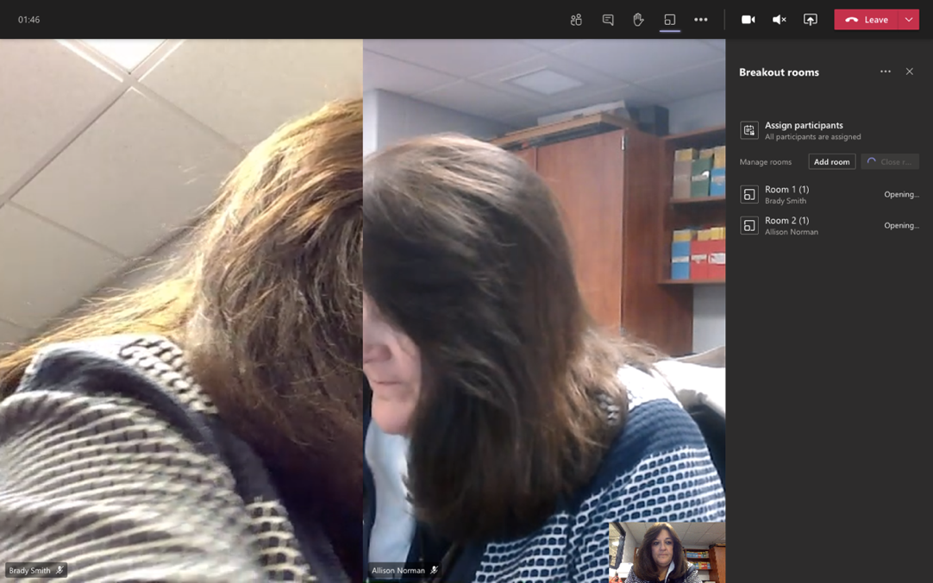

The word “opening” will appear as Teams begins to move students from the main meeting into their breakout rooms.

Students will get the above notification when they have been moved to the breakout room meeting.

Teachers can join whatever breakout meetings they would like. Just click on the three dots to the right of the room, and click Join Room.

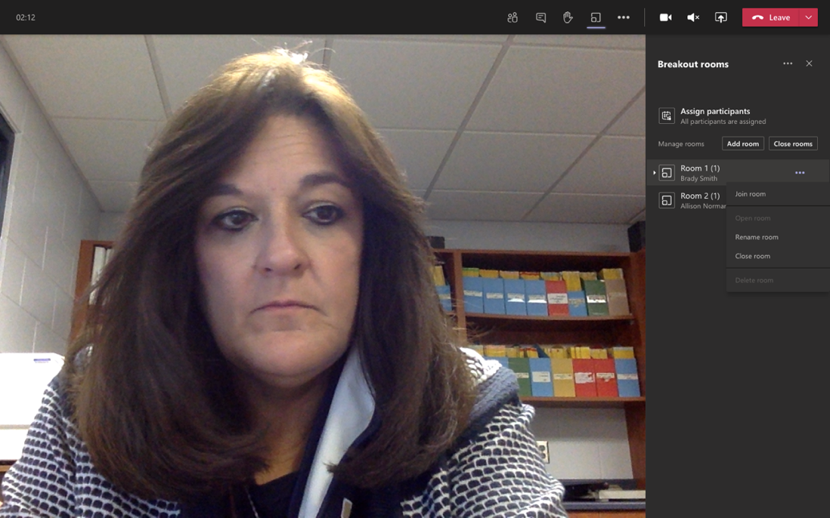
To leave a breakout room and return to the main meeting, simply click on return to main meeting at the top of the screen.

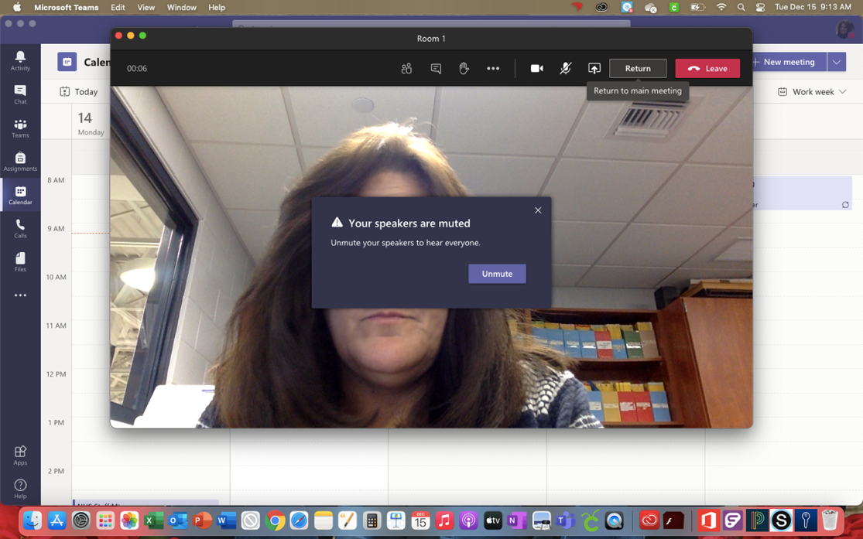

When you want the students to return to the main meeting, you just need to close all the rooms.
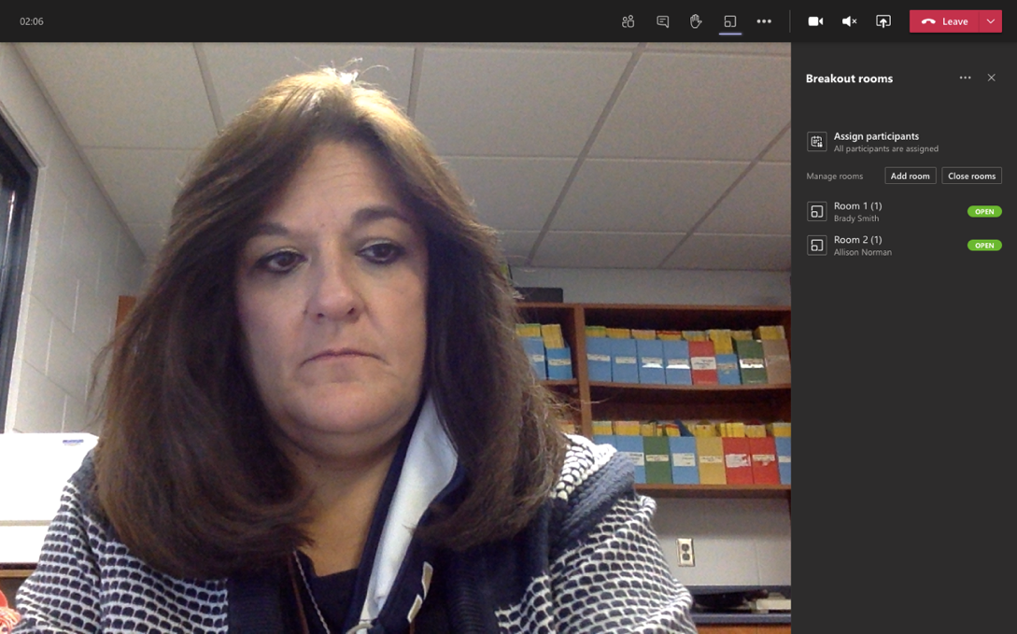

Once you close the breakout rooms, students will get a notification that they have rejoined the main meeting.

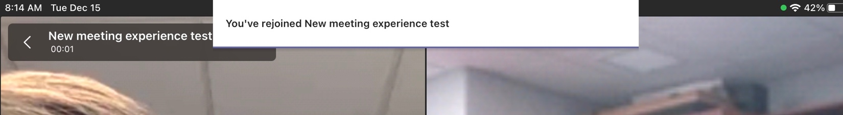
Students cannot rejoin the main room or rejoin the Breakout Room without you doing it for them. If you want you can change that by going to into room settings. This can be found next to the three dots next to Breakout Rooms.

If you would like to learn more or watch a video for a step-by-step tutorial, click copy and paste the link below into your browser.

https://www.youtube.com/watch?v=DMfsilBhW7A

