Getting Started: Educators

Welcome to Flipgrid! To receive your student’s videos, take 5 minutes to set up your account, and share your first Topic. Topics are discussion prompts that you create and your students respond to that prompt with a short video.

Step 1: Sign up for a free educator account
Go to https://admin.flipgrid.com and sign up with Google or Microsoft account.
Tip – choose Google if your school uses Google Classroom, Docs, and Drive. Choose Microsoft if your school uses Word, OneDrive, or Microsoft Teams.
Use your school provided email to sign up and provide some information about yourself and school.

Step 2: Add a Topic and Choose Access
To create Topic, add the Topic Title and prompt for your students. Topic Media is a good way to add reference material links, an image, or GIF to your topic.
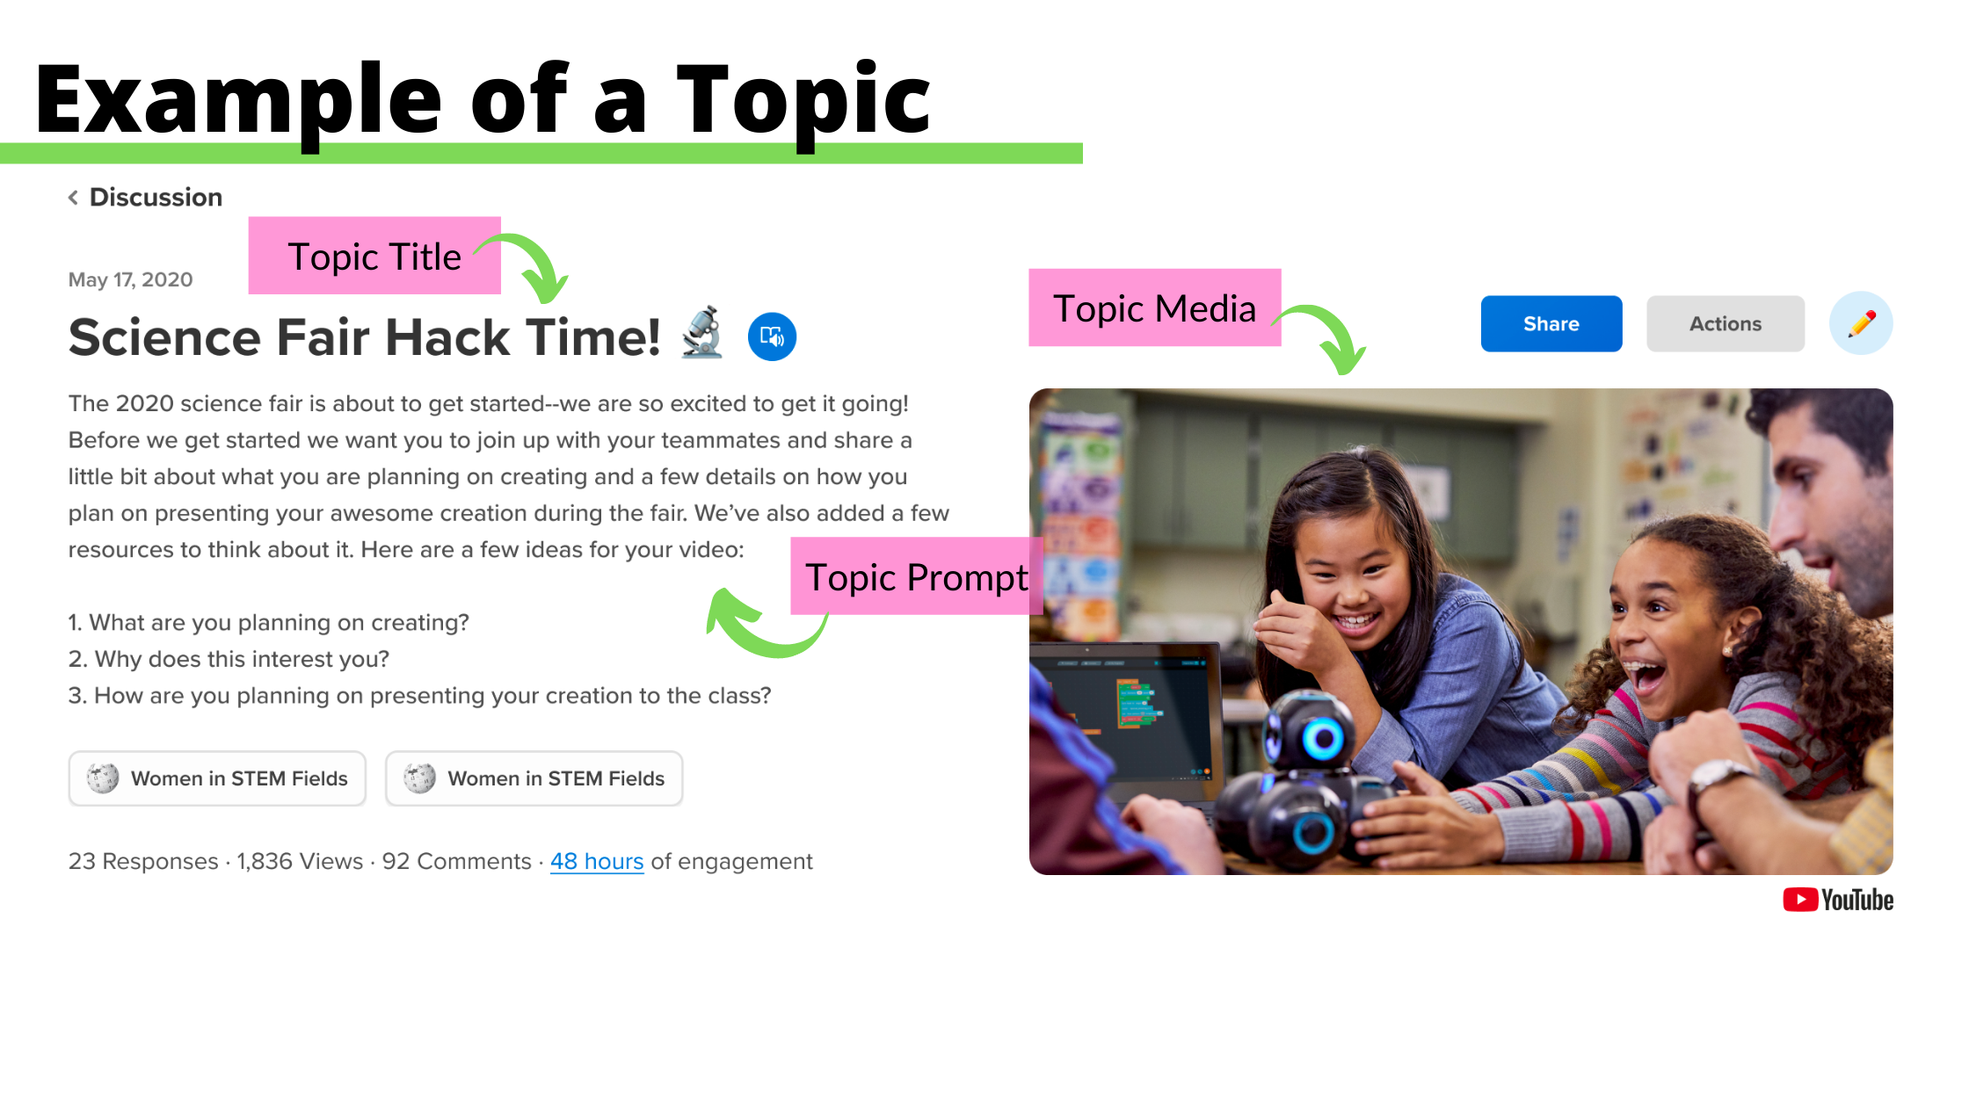
Tip – Turn on video moderation if you want to review a video response before anyone else views it. Once you approve a video, then everyone else can view the video.
Choose how students will join the Topic with Private or Public access.
- Private access is for class discussions. Choose Student Email if your students have school provided emails. Choose Student Username if your younger students don’t have emails.
- If you want to include families in your class discussion, then add a Guest Password.
- Public access is primarily for adult educators and professionals to have broader community discussions.

Step 3: Share the Topic
Share the Join Code or link with your students, families or community. If you created usernames for younger students or a guest password for families, make sure to share those too.
- Students receive the join code or link and must log in with their email or username.
- Families receive the join code or link and must log in with the guest password.
- Adult educators and professionals in a Public Topic receive the join code or link and can view videos, but must log in with their email to record a video.

