Using Microsoft Stream in Teams

If you are looking for a way to get longer videos to your students (ones that are too big to put in Schoology) or simply want a place to organize, store, and share your lesson videos, Stream is a great place to do that! When you create a Stream Channel, you can add that Channel to your Group or Team (Classes). Here’s how to get started!

- Go to Office 365 and login if you aren’t already logged in.
- Find the Microsoft Stream icon and click on it. It looks like an arrow. If you don’t see it, click on All Apps.
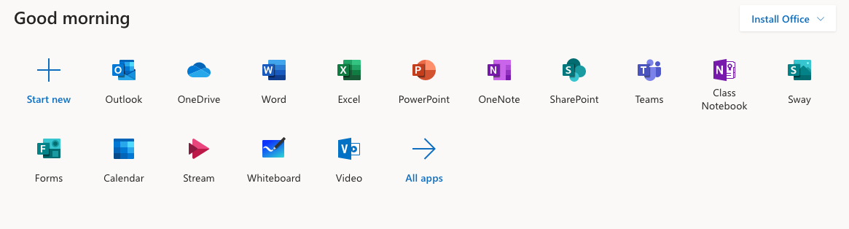

- Once in Stream, click on Create at the top of the screen. Click Channel.
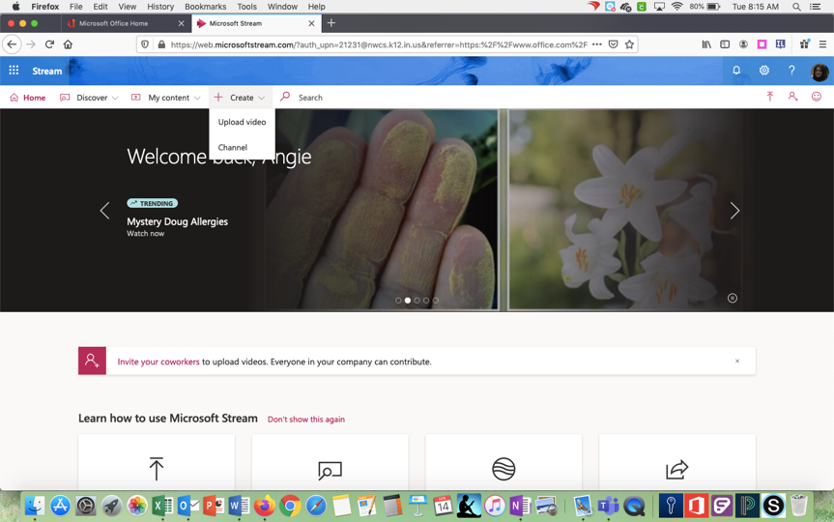

- Name the channel. Start typing in the name of the Group you want to have access
to this channel. They will pop up on the screen for you to choose. The name you type
must match the name of the group in Teams, so you may need to double check to be sure you have it right. You can even upload an image for your channel if you want. Click create when you are done.

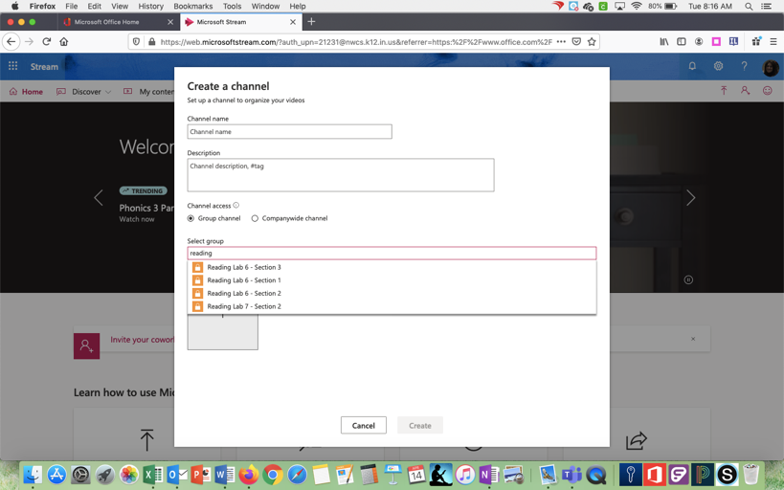

- If you have recorded a lesson using Teams or Stream, we can add that video into a channel for your class to view. Go to My Content at the top of the screen and click Videos. Click on the pencil to the right of the video to rename it. . . probably the topic of the lesson and the date.

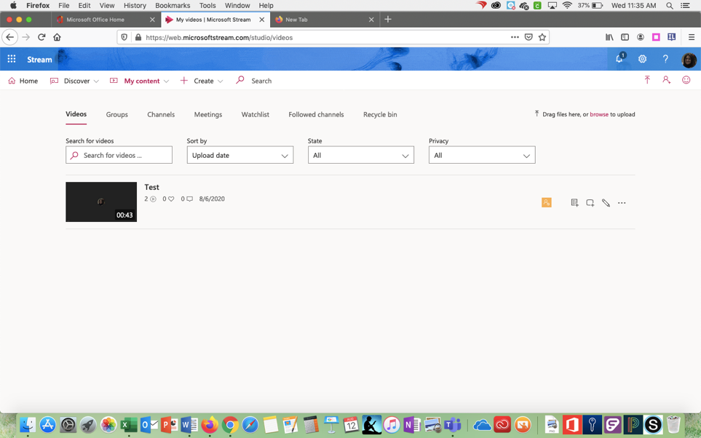

- Under the permissions tab, be sure the “allow everyone in your company to view this video” is unchecked (unless you want everyone to see it). Where is says “share with” choose channels. Type in the name of the channel you just created. Click Search. Select the channel. Click Apply.

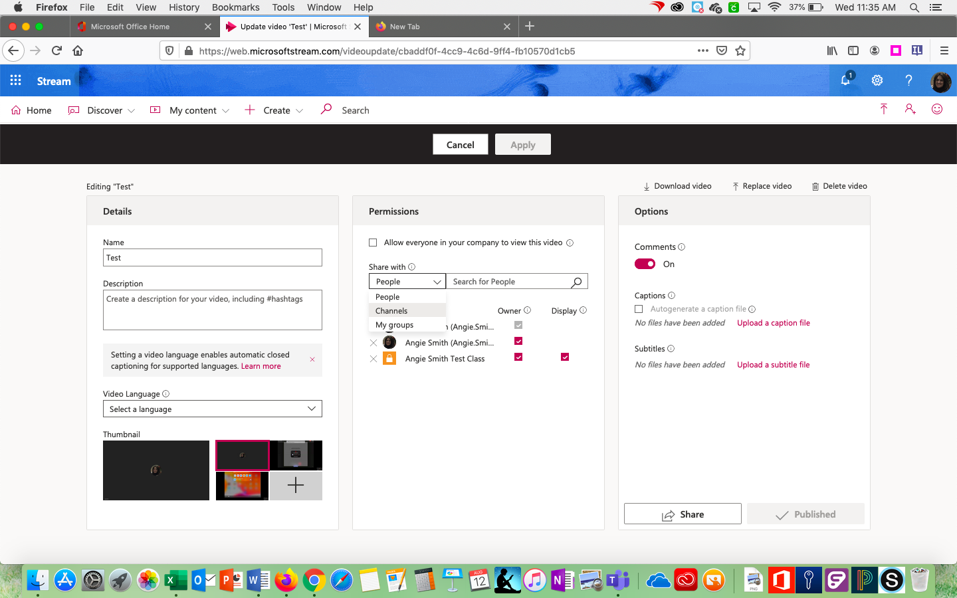

- Once you have created a channel and added content, you can add the Stream channel to your
Groups/Teams in the Teams app. This makes it easy for students to see the lessons you have recorded.

- Open Teams on your Mac. Go to the Team or Group for which you just created the channel. You might have to click on All Teams in the upper left corner to see all your choices. Remember, you can hide the teams you don’t want to see by clicking the three dots next to the name in the box.

- Once you have opened the Team or Group’s page you want, click on the plus sign at the top of your
Team page.

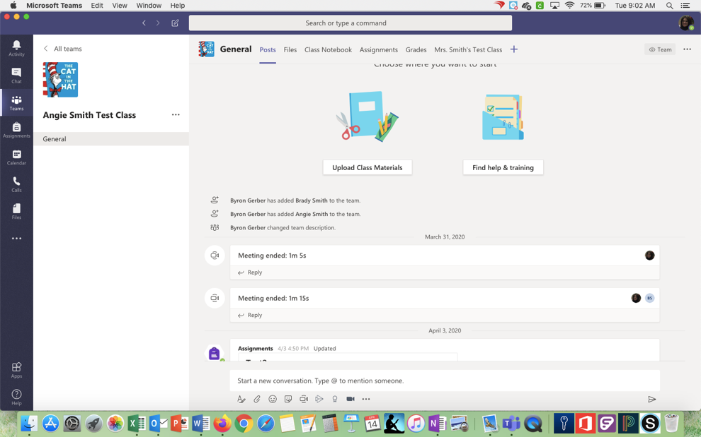

- Choose Stream.
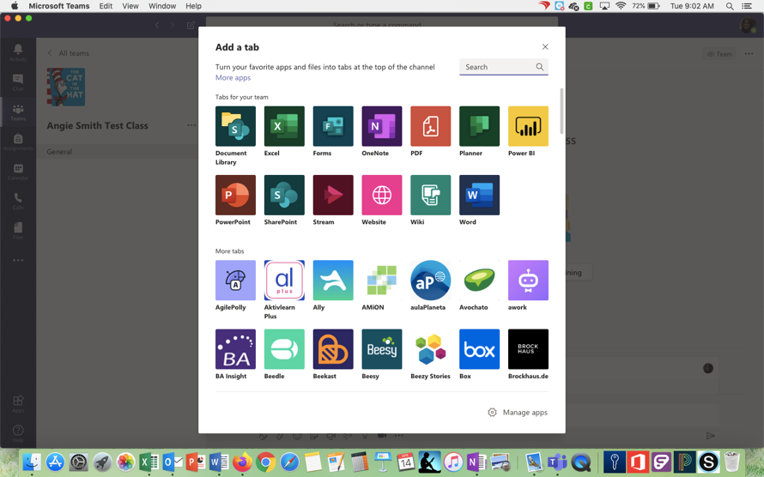

- Type in the name of the channel you created or paste in the URL from Office 365.
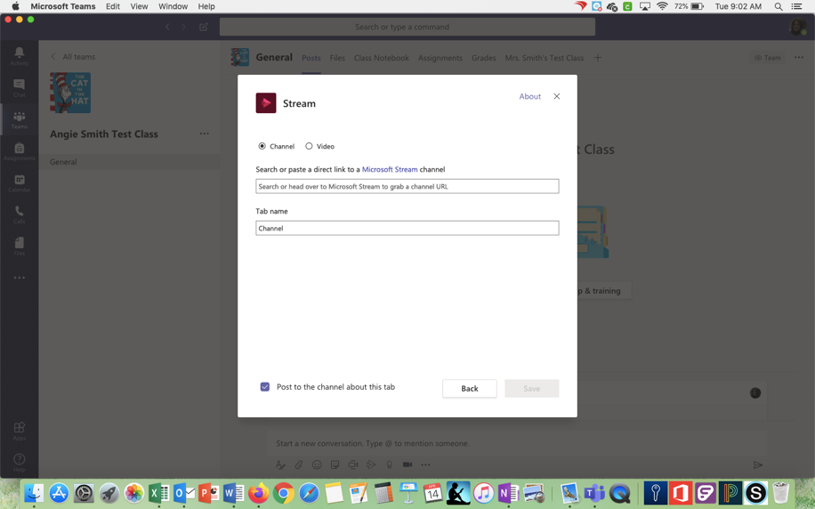

Now, when kids want to see the videos for your class, they just tap on the tab at the top of the screen with the name of the channel, and all videos you have posted will be stored in that channel’s tab in Teams!

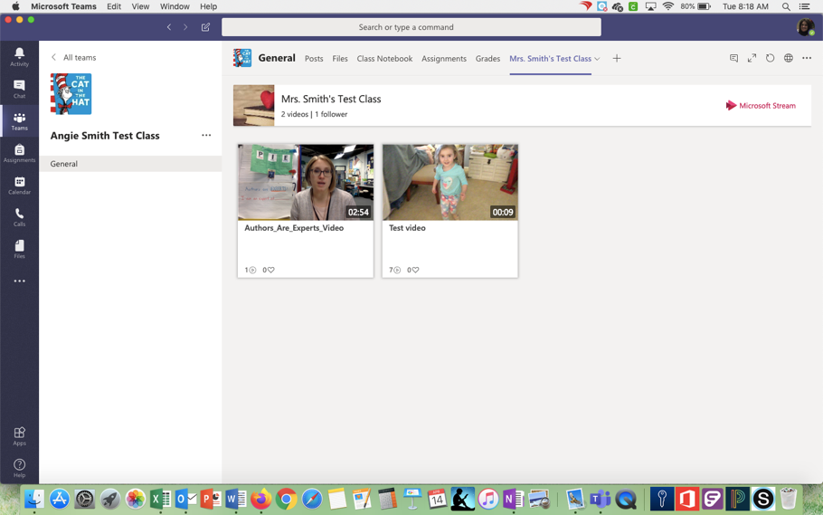

**You will need to create a channel and share it with each of your courses.

You can also add videos to your channels that you may have downloaded or created elsewhere. To do that, simply go to Office 365 and click on Stream. Go to My Content. Channels. Choose the channel in which you want to upload the video. Once on the channel’s page, in the middle of the screen, it will say “Select More Files to Upload.” Click on that and select the videos you want to upload.

For more information on Stream visit: https://educationblog.microsoft.com/en-us/tag/microsoft-stream/

