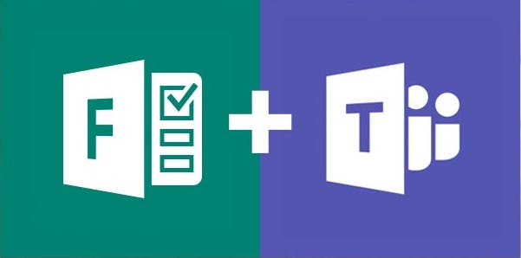

Microsoft Forms and Teams

If you are looking for a quick way to check in with your remote learners after a Teams meeting, Forms is a great tool to use. Whether you want to touch base to see how they are doing or want to do a quick check for understanding, Forms is fast and easy!

To get started, find the Team (Class) in which you want to create the form.
Click on the Posts tab at the top of the screen.

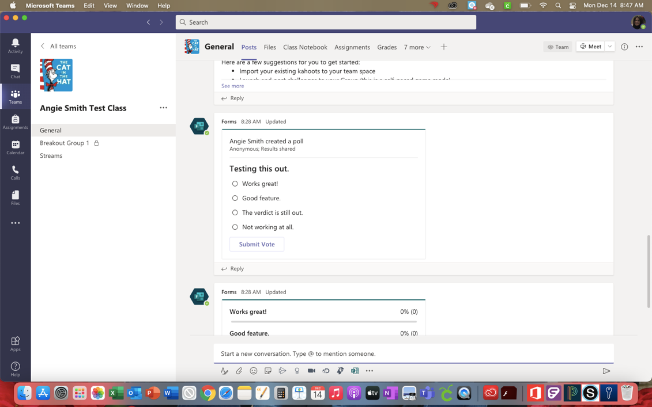

Click on New Conversation at the bottom of the window that appears.

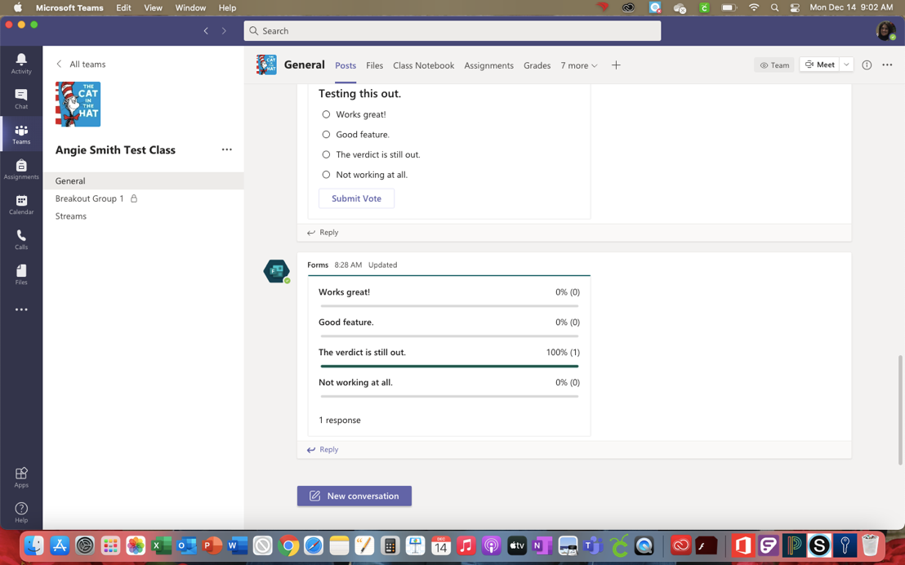

The Forms icon should be at the bottom of the screen. It looks like an F next to a paper.

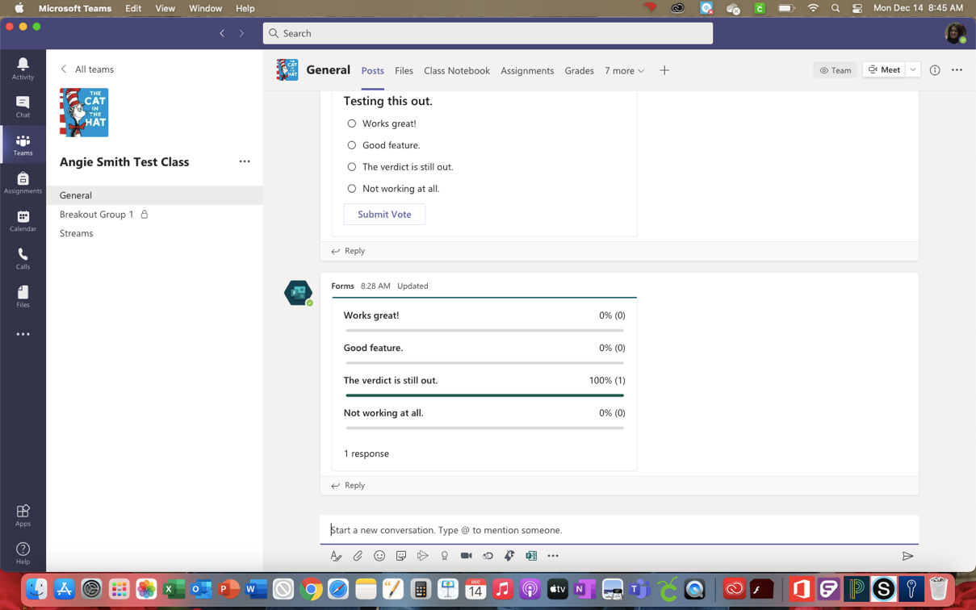

If you don’t see the Forms icon, just click on the three dots to show more and choose Forms from the list.

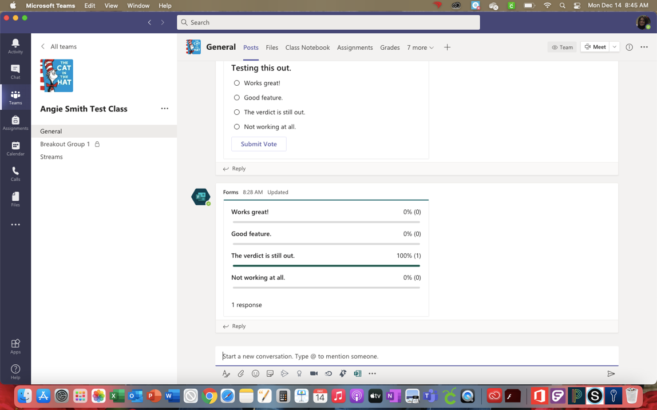

Once you find the Forms icon, click to open it. Now you can create a multiple choice or multiple select question for students.

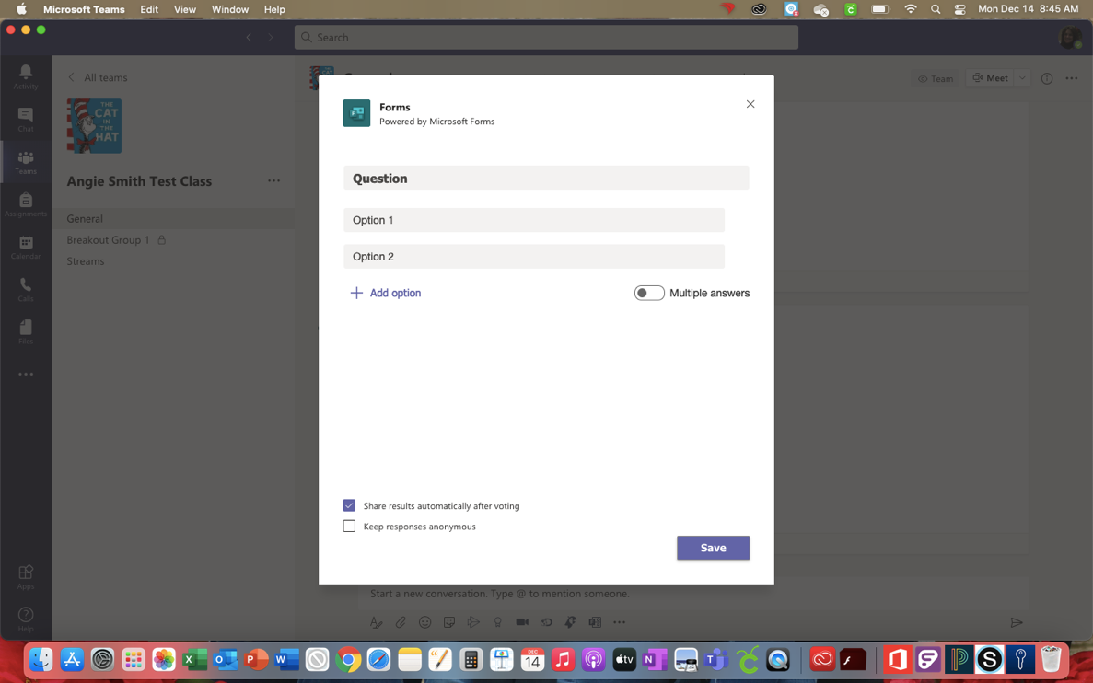

After creating the question, you can choose to show the results automatically to students and to keep the responses anonymous. If you show results but keep them anonymous, students will be able to see how the class responds overall, but they will not be able to see how individuals responded.

Once you click Save, you will be brought to a Preview Screen, so you can check to be sure the question looks the way you want it to.

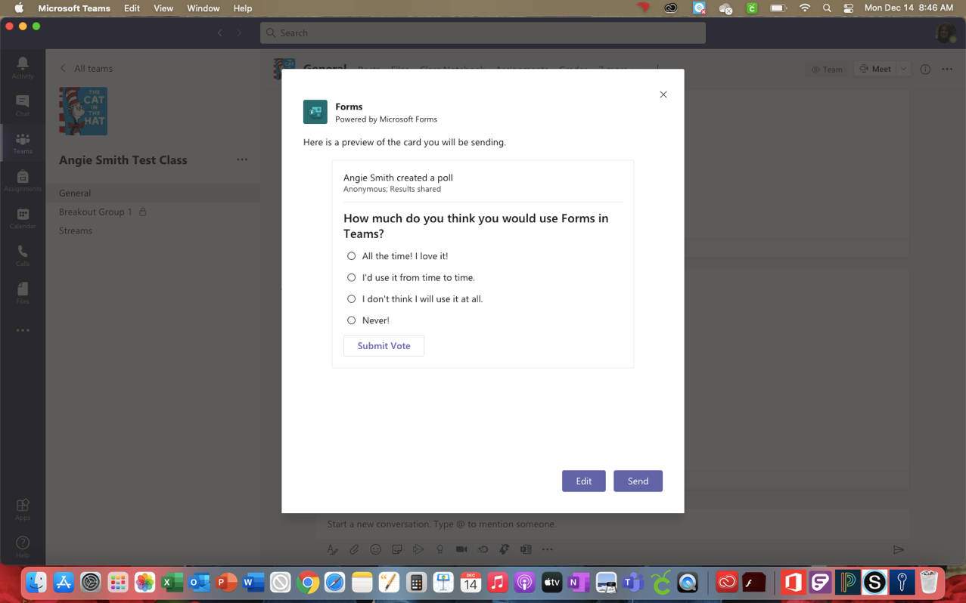

If you like the way the form looks, click Send. It will then show up in your Posts within the Team you chose. If you don’t like it, click Edit to work on it some more.

