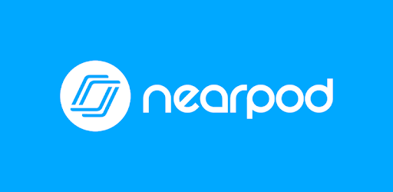

Nearpod is an interactive instructional tool that allows students to view teacher-created slides (created in Nearpod or Power Point), participate in polls, draw responses, watch videos (created for Nearpod), view images, and answer multiple choice questions. They can also view content from the web (excluding YouTube which is still blocked). They can go on virtual field trips, listen to audio files uploaded by the teacher, and answer fill in the blank and open-ended questions. Students can participate in matching activities and memory tests as well. Students can even draw on top of teacher created slides! So, they can annotate small passages of text, circle right answers, and work out a math problem. Nearpod and another tool we have talked about, Flipgrid, work well together, too. You can embed a Flipgrid topic within a Nearpod presentation!

Students can participate live or at their own pace, which makes Nearpod a great tool to use for remote learning / eLearning days. Once students submit their responses in Nearpod, teachers even get a report showing what students completed it. Teachers can view student’s drawn responses and answers to other questions.

To get started, teachers simply need to create a free account. One drawback to the free account is that you get 100 MB of storage space. So, it will be necessary to delete some items in order to make room for more.

Once in Nearpod, teachers can either create their own presentations from scratch, upload slides from Power Point, or select pre-made presentations from the Nearpod Library. Pre-made presentations can even be edited, so teachers can customize them to fit their needs. File formats that can be uploaded include Power Points, PNG files, and PDFs.

To get started be sure you have clicked My Library/My Lessons.
- Click Create at the top of the screen.
- After clicking Create, choose Lessons.
- Click on Untitled Lesson at the top of the screen. Name your presentation.
- At the bottom of the screen, you can click on Upload Files to load a PNG (picture file), PowerPoint, and PDF. When uploading a PDF, if it is more than one page, you will have the option of inserting the PDF pages on different slides or using the PDF Viewer which allows students to scroll to see the different pages.
- Now click on Add Slide.
- You have two tabs at the top of the screen: Content and Activities.
- Content is where you can add Nearpod content or content you have created. When you click on Video, you have the option of using Nearpod videos or of uploading a video of your own. YouTube videos will not play for students unless you have downloaded them and uploaded them as a file. In the videos, you can embed questions to check for understand! You can also add slides of text, images, and short videos. In addition to these options, you can also insert web content, a Nearpod 3D image, a simulation / game, a virtual field trip, a PDF viewer that will allow kids to see a PDF (but not write on it . . . that is another option), a Sway presentation, and more.
- Add Slide and choose the Activities tab, you can insert your own questions and content for students to work with in many different ways. There are lots of options here for students to demonstrate their learning. You can ask them open-ended, multiple choice, fill in the blank, and matching questions. For some questions, you can allow students to record answers, and you can record instructions through audio or video. You can even add images to those questions. Students can participate in polls and collaborate on a “white board.” Finally, you can choose to give students a Draw It question. This question allows students to write and draw answers. If you don’t upload a background, they will write on a white board. If you upload a background, they can draw on it and insert text.

Other important features to talk about are in Settings. Click on the Nearpod icon at the top of the screen. Then, click on the icon of a person in the upper right-hand corner. Click on Lesson Settings. Two of the more important settings that you might want to turn on here are allow collaborate board for student paced lessons and immersive reader (which will read text to students).

Once a presentation is complete, teachers simply choose to share the presentation live or to allow students to participate at their own pace. When a teacher chooses to share a presentation, a code is generated. Teachers simply need to share the code with their students. Students open the Nearpod app on their iPad, enter the code, and then enter their first name. That’s it!

