Teams: The New Meeting Experience

Microsoft has released an updated version of Teams for the Mac/PC. This updated version has a few nice features for teachers! To gain access to these new features, you must first enable the new meeting experience. To do that, simply find your initials in the circle in the upper right-hand corner of the Teams app. Click on it. Click on Settings. Click on “Turn on new meeting experience.”
Here are some of the new features:

- Large Gallery: When you launch a Teams meeting from your Mac or PC (and there are 10 participants or more with their video turned on), you can choose to view a “Large Gallery” view on screen. This now lets you see up to 49 participants on your screen at one time!
- Together Mode: When you have 10 or more participants in a meeting who have their video turned on, you can switch to “Together Mode”. This removes the squares and places participants in what looks like an auditorium setting.

The toolbar is now stationary at the top of the screen. To access Large Gallery and Together Mode, click on the three dots for more options. They are listed under Gallery. Remember, 10 or more participants must have their video on for this to be an option.

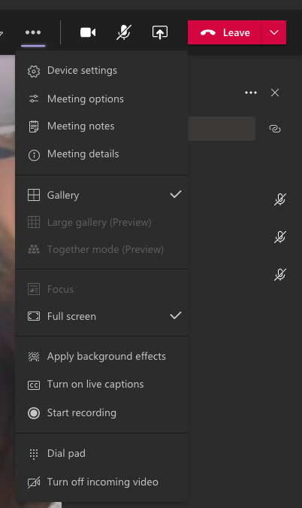
- Spotlight: Teachers can now put themselves in “Spotlight.” Which will make them the large view on student iPads (instead of being the same size as everyone else on screen). This is EXTREMELY helpful when teachers are demonstrating something in the classroom or writing on a Smartboard or white board. Now, students will be able to better see what you are doing. In addition, if teachers put themselves in “Spotlight” and then share their screens, students will see the teacher’s screen share on the left and the teacher on the right. This is something teachers have been asking for! Now the kiddos can see both your presentation and you at the same time! Teachers can also put their students in “Spotlight”. Prior to the “Spotlight” function, students had to “pin” their teacher in order for the teacher to appear larger on their screens.

To use Spotlight, first click on the participants icon. Then, click on the three dots next to the person you’d like to spotlight.

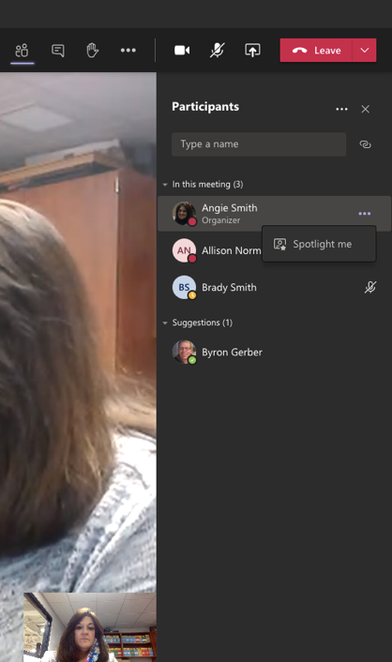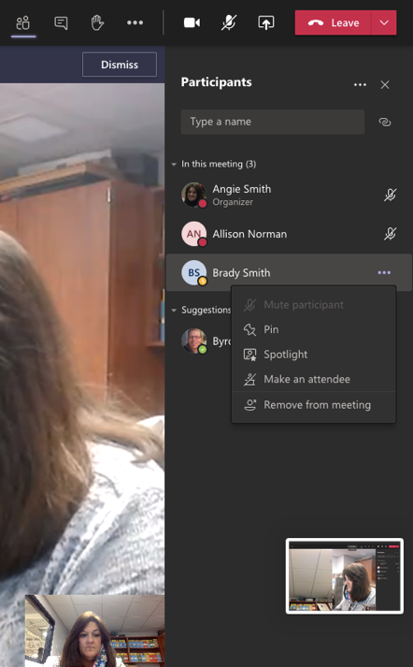

To stop the spotlight, select Exit spotlight at the top of the screen for the teacher. For students, click on the participants icon at the top and the three dots next to the student’s name. Then, click on stop spotlighting.
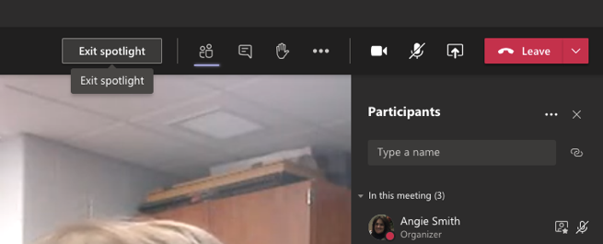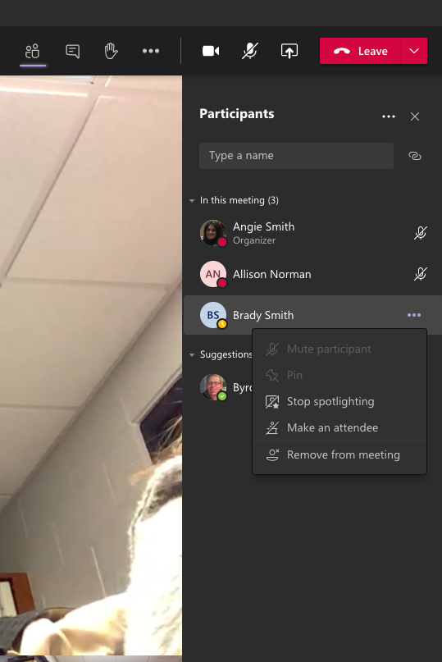

- Highlighting Students with Questions: Nothing needs to be done for this one. However, now when a student raises his or her hand in a Teams meeting, a yellow box will light up around their picture. The box doesn’t stay long (about 30 seconds) but it does help to alert the teacher to a question. The hand will still show as being raised next to the student’s name in the participants’ box. In addition, there will be a red number next to the participant icon at the top of the screen.

- End Meeting: Instead of just leaving a meeting, teachers can
now end a meeting, which forces everyone out of the meeting. Students will not be able to hang around after the meeting ends. If teachers enable the lobby when creating meetings, students will not be able to enter a meeting without being admitted by the teacher. This will prevent students from having unsupervised meetings.

