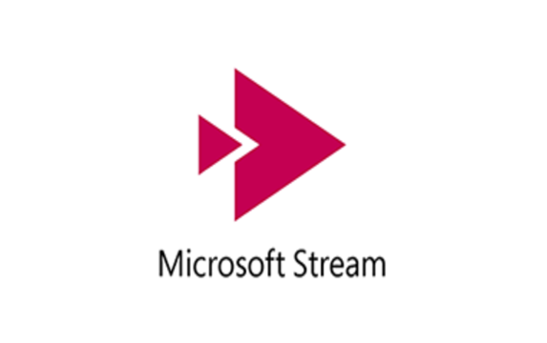
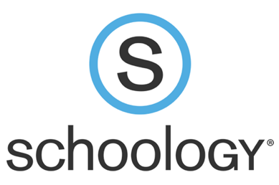
As we think about providing classroom instruction for our students both in person and remote, there are many tools and processes to consider.

One way you can provide instruction to remote learners is by recording your lessons via the iPad app Stream. The app is very user friendly and uploading videos to the cloud is simple. For more information on how to do this, click this link: https://nwcsk12-my.sharepoint.com/:w:/g/personal/21231_nwcs_k12_in_us/EUwjg-fbigZGvAnY6f8Bx7EB_wIUFy5xfMNrCbVssrURbw?e=04GfMF

Once a video is in Stream, it has to be shared with students. Stream is very particular about protecting videos, so you will need to create a channel so your students can access the videos you upload. For more information on how to do this, click this link: https://nwcsk12-my.sharepoint.com/:w:/g/personal/21231_nwcs_k12_in_us/EXZoVvxY8vBHiUAG9UTggjsBNcaCczr_JDo6MrWhh4ZSkw?e=zl3Ycn

Once you have recorded a video, uploaded to Stream, and created a channel for your students, you are ready to share the video with kiddos. If you followed the above steps and created a tab in Teams for your students, they can go to More in the Teams app, and click on the tab for the video channel to see all your uploads.

If you want, you can just put a link to the video in Schoology. As discussed before, Stream is protective of videos. So, you will still need to have a channel to which you upload your videos and share with your students. If you already created a channel following the steps above, you are ready to get a link to that video to share. To do this, go to Stream in your browser. Go to My Content/Channels. Find the channel you created and open it. Find the video you want to share. Click on the three dots to the far right and click Share. Copy the link. Go to Schoology and share that link.

Students must have the Stream app downloaded from the app portal and be signed in (number@stu.nwcs.k12.in.us and password) for this to work. They should only have to login one time.

As always, if you need anything, please don’t hesitate to reach out to me! I am happy to help! (angie.smith@nwcs.k12.in.us or ext. 7172)

