Using Teams with new student Restrictions.

Calling Students
1-on-1 calling has been disabled for students, including teachers calling students. You can still have a call with a student by 1st scheduling a meeting with just that student.
- Open Teams
- Select the Calendar
- Select New Meeting
- Add the student to the Required Attendees.
- Fill out the meeting times
Now you can both join the meeting and have a video call, share screen, etc.

Chatting with students
Chats outside of a team have been disabled, including group chats (the chat button at the bottom of the Teams app on their iPad will be removed).
You can have group chats inside your teams, you can create channels for different types of topics, and chats. If you need to have more private conversations, see information below on creating private channels.

Create a private channel

If you want a focused place to discuss sensitive information for a single student or a small group of students and so on, create a private channel for your team. Only owners or members of the private channel can access it. To understand who can view what in a private channel, see Private channels in Teams.
You can create up to 30 private channels over the life of a team.
To create a private channel for a team:
- Go to the team you want to create the private channel for and choose More options > Add channel.
- Enter a name and description for your channel.
- Under Privacy, select the down arrow on the right, and then select Private – Accessible only to a specific group of people within the team.
- Select Add. This adds a private channel to the team.
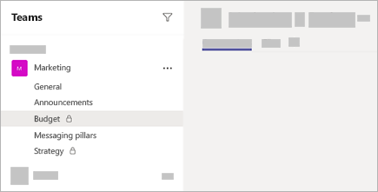

Add members to a private channel
As a private channel owner, you can add or remove members, and edit private channel settings. Each person that you add must first be a member of the team.
To add members of your team to a private channel:
- Next to the private channel name, select More options > Add members.
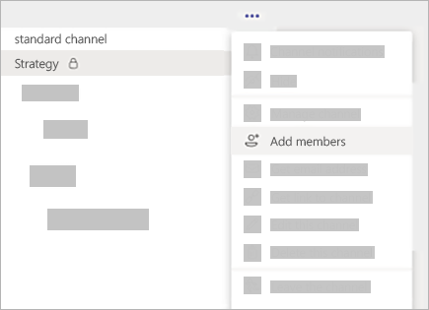
- Use the Members and Settings tabs to add or remove members and assign roles. Your private channel can have multiple owners and up to 250 members.
- When you’re ready, select Done. Members can now post messages in the private channel.

Managing student’s ability to comment on different channels.
In Microsoft Teams, team owners can turn on moderation for a standard channel to control who can start new posts and reply to posts in that channel.
In Teams, go to the channel, click More options ... > Manage channel. From here you can turn on and turn off moderation, add team members as moderators, and set preferences.
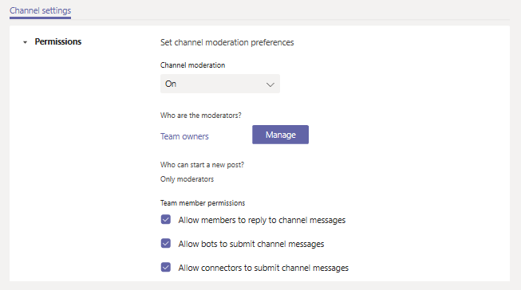

Turn on or turn off moderation for a channel
By default, moderation is off, which means that the usual channel settings apply to team owners and team members. For example, you can restrict new posts to only team members or allow everyone, including guests, to start new posts.
To turn on moderation for a channel, under Channel moderation, click On. When channel moderation is on, only moderators can start new posts.

Add or remove channel moderators
Under Who are the moderators?, click Manage, and then add or remove team members as moderators. Team owners and moderators can add and remove other moderators.

Mute students in a team or a message.
Mute students from commenting in class conversations. This means students will no longer be able to see an inappropriate comment and that the muted students can no longer post or reply in class conversations. You can un-mute students at any time.

Mute students in settings
- Select More options on your team's tile.
- Select Manage team.
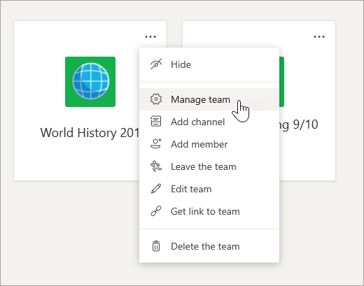
- Select the Members tab. You’ll see your students listed. Select the checkmark box under Mute students to prevent students from commenting or select the top checkbox to mute all students at once.
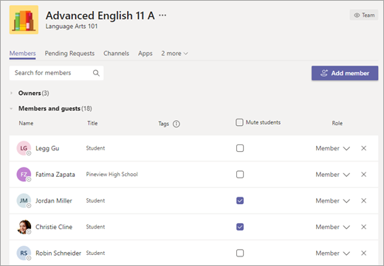
Note: Un-mute students by returning to settings and de-selecting the checkbox next to their names.

Mute a student from a message
- Navigate to the student message you want to mute.
- Select More options next to the student’s post, then Mute this person.
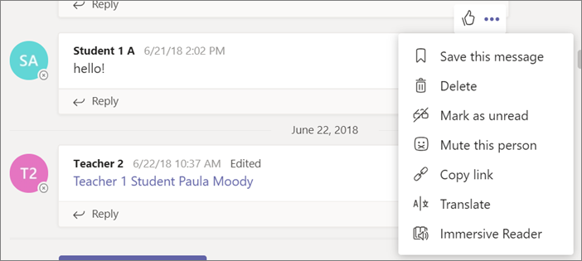
To un-mute the student, follow the instructions above in your class team settings.

